Note: Include this page only when adding / amending / deleting a document. If using this document as a record, this Revision History page can be omitted.

REVISION HISTORY

Revision no | Date | Description of Changes | Reason for Revision | Revised by | Approved by
1 | 07 Dec 12 | - Add revision history page  - Updated record names in Quality Records section  - Add preparation of PM Plan in the procedure | - Recommendation from Stage 2 audit  - To make document names more descriptive of its function  - Address Q4 2012 IQA observation | CMRojas
2 | Apr. 8, 2016 | Added disclaimer when printing the document | For document control | RCGanal | ARAlacar
TM-BR-MG- 11 Rev02, 10302015

- Objective
To address potential problems in IT infrastructure before they become failures.
- Scope
This procedure defines the action and responsibilities of the staff of the IT unit to prevent the breakdown of IT infrastructure before they happen. This includes activities from the start of the scheduled preventive maintenance until the time the preventive maintenance report is submitted to the management committee for their review.

- Definition of Terms
PM | Preventive Maintenance
Management Committee | The committee composed of the company President, Vice-President, Sales and Marketing Champion, Vice-president for Finance, Chief Information Officer and all the unit heads.

- Procedure Details
RESPONSIBLE | ACTIVITY | INTERFACE
IT Head  Technical support  IT Head | 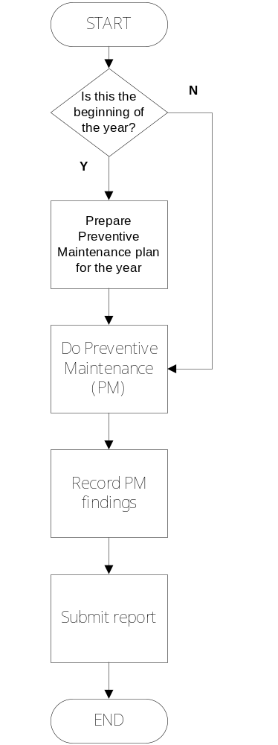 | Preventive Maintenance Plan  Preventive Maintenance Checklist  Preventive Maintenance Report  Service Delivery  Management Committee  PM Summary Report

- References
- Machine User Manuals
- Preventive Maintenance Plan

- Quality Records
- Preventive Maintenance Checklist
- Preventive Maintenance Report

